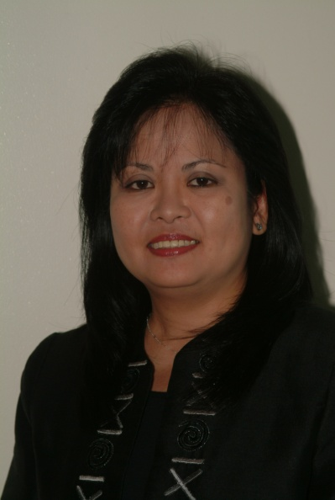

Ms. Adelina C. Santos-Borja is the Officer-in-Charge of the Resource Management and Development Department and Head of the Carbon Finance Unit of the Laguna Lake Development Authority in the Philippines. She is also a Scientific Committee Member of the International Lake Environment Committee Foundation (ILEC).

At present she is engaged in the Research Project on “Managing Environmental Risks to Food and Health Security in the Laguna Lake Watershed” of the Research Institute for Humanity and Nature in Japan together with the University of the Philippines at Los Banos and in Manila.

Ms. Santos-Borja has broad experience in the field of Limnology, Environmental Impact Assessment, Water Resource Development and Management, Stakeholders’ Participation, and Clean Development Mechanism. She obtained her Master of Science in Biology and Master of Science in Environmental Science from the University of the Philippines. As a UNESCO fellow, she participated in the Post-Graduate Training Course in Limnology of the Austrian Academy of Sciences and the University of Vienna. She trained on Lake-Water Quality Management conducted by ILEC and on Resource and Environmental Management by the Australian National University. She also completed the Temasek Foundation Water Leadership Program at the Lee Kuan Yew School of Public Policy of the National University of Singapore.

She was twice the recipient of the Ibaraki Kasumigaura Award as the author of one of the ten best papers on lake conservation and management during the World Lake Conference in 1997 and 2003. She was also instrumental in the acceptance of Laguna de Bay as a member of the International Living Lakes Network, a flagship project of the Global Nature Fund based in Germany.

Ms. Santos-Borja is one of the authors of the World Lake Lake Vision (2003) and the World Lake Vision Action Report (2007). She was also one of the resource persons in ILEC’s internationally published report on “Managing Lakes and their Basins for Sustainable Use: A Report for Lake Basin Managers and Stakeholders.” She has also presented various papers in international and local conferences on lake basin management, water quality management, sustainable partnerships on resource conservation and clean development mechanism, some of which were published in international journals.

